

Industrial Timers

Solid State Relay



October 21, 2022

Electronic relays india pvt.ltd..

P.B.No.2254,93A,Industrial Suburb, ll Stage,Yeshwantapur,Bangalore-560 022. INDIA

Ph.:23371434, Telefax: 91(080) 23470048,E-Mail:admin@eri.co.in

**Contents**

|  |  |  |
| --- | --- | --- |
| **Sl.No** | **Topic** | **Page No** |
|  | Introduction |  |
|  | Circuit Design |  |
|  | Simulation |  |
|  | Prototype |  |
|  | PCB Design |  |
|  | Code |  |
|  | BOM |  |
|  | Comparison |  |

***Introduction***

Solid state timers—also known as solid state relays or solid state timer relays—are used in numerous electrical and electronic devices to control of a wide variety of resistive and inductive loads. The performance characteristics and other numerous benefits of solid state timers over their electromechanical counterparts make them ideal for a broader range of switching applications such as:

* Heaters
* Lights
* Motors
* Motion control devices

**Solid State Timers**

An appreciation of the concept of relays, in general, will help to better understand solid state relays. Relays are switches that open or close a circuit when actuated by an electrical signal. They are used in applications where it is necessary to control one or more circuits via a lower and typically isolated power signal. Traditional relays Solid State Timer are controlled by electromechanical means. A small current is used to energize an actuator coil, which in turn generates a magnetic field to open or close a switch with movable metal contacts.

Solid state timers and controllers perform a similar function – however, these devices consist of no moving parts. Instead, solid state timers utilize the electrical and optical properties of semiconductor elements such as thyristors, triac’s, diodes, and transistors to perform isolation and switching functions. A typical solid state timer employs optical semiconductors, known as photocouplers, to isolate input signals by converting electrical signals into optical signals.

Some of the most common types of solid state timers include:

* Zero-switching
* Instant-on
* Peak-switching

These different types of timers allow switching operations to be performed at different times—either instantaneously or delayed—depending on the position of the voltage on the AC sine wave.

* Zero-switching relays are the most common type of timer relays used currently. These switches turn on the load when the control voltage is applied and the voltage crosses the zero point on the AC sine wave, resulting in a slight delay of the turn-on of the solid-state timer. The load is switched off when the control voltage in the relay is removed.
* Instant-on switches, on the other hand, turn on the load immediately when the control voltage is activated. Therefore, the load is turned on at any point of the sine wave making it ideal for precise control applications.
* Peak-switching timer relays, as their name implies, turn on the load when the control voltage is activated, and the voltage of the load is at the peak position on the sine wave. As with the other relays, the relay turns off when the control voltage is removed.

**Benefits and Limitations of Solid State Timers**

* One of the main advantages of solid state timers is the lack of mechanical or moving parts in the device. Since there is no opening or closing of contacts, solid state timers are not susceptible to mechanism wear such as arcing and pitting. As a result, solid state timer relays can operate for countless on/off cycles without deterioration in performance.
* In addition, with no moving parts, noise is eliminated. The silent operation of solid state timers is especially beneficial in power cabinets that may contain dozens of timer relays. Additionally, the lack of mechanical components means that solid state timers offer significantly faster response times than their electromechanical counterparts. Instant-on solid state devices can typically communicate on/off signals from the control circuit to the load circuit in under 20 microseconds, making them ideal for fast-acting electronic devices.
* Furthermore, most solid state timers require significantly less power than electromechanical switches to activate the control and load circuits. For instance, most solid state timers can actuate load circuits with as little as one milliamp in the control circuit with voltages as low as three volts DC.

The disadvantages of solid state timers can be considered to be minor, depending on the specific application. Some of these include:

* Higher resistance and heat generation when closed, so heat sinks or other cooling mechanisms are typically required
* Lower resistance, and a possibility of leakage current when open
* Non-linear voltage/current characteristics
* Higher transient reverse recovery time due to the presence of diodes
* Some solid state relays may also be sensitive to changes in polarity

Solid state timers offer numerous performance advantages over electromechanical switches for many applications. Although they do have some limitations, they are far outweighed by the benefits that these timers offer.

**Circuit Design**

1. 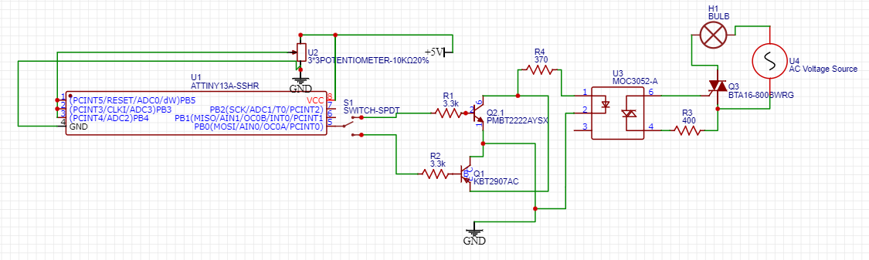**Software Based  
     
     
     
     
     
     
     
     
     
     
     
   2) Hardware Based**

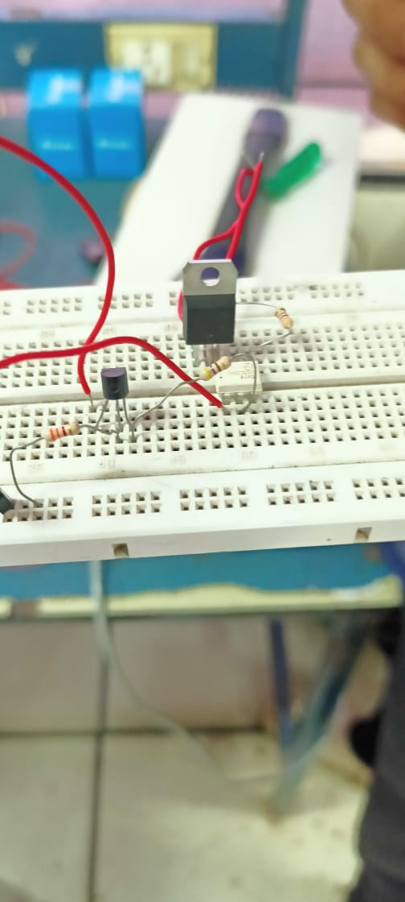

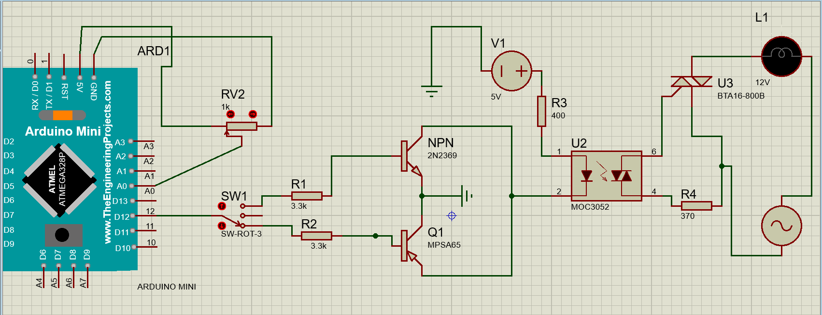**Simulation (Proteus Software)**

**Build Samples (Prototype)**

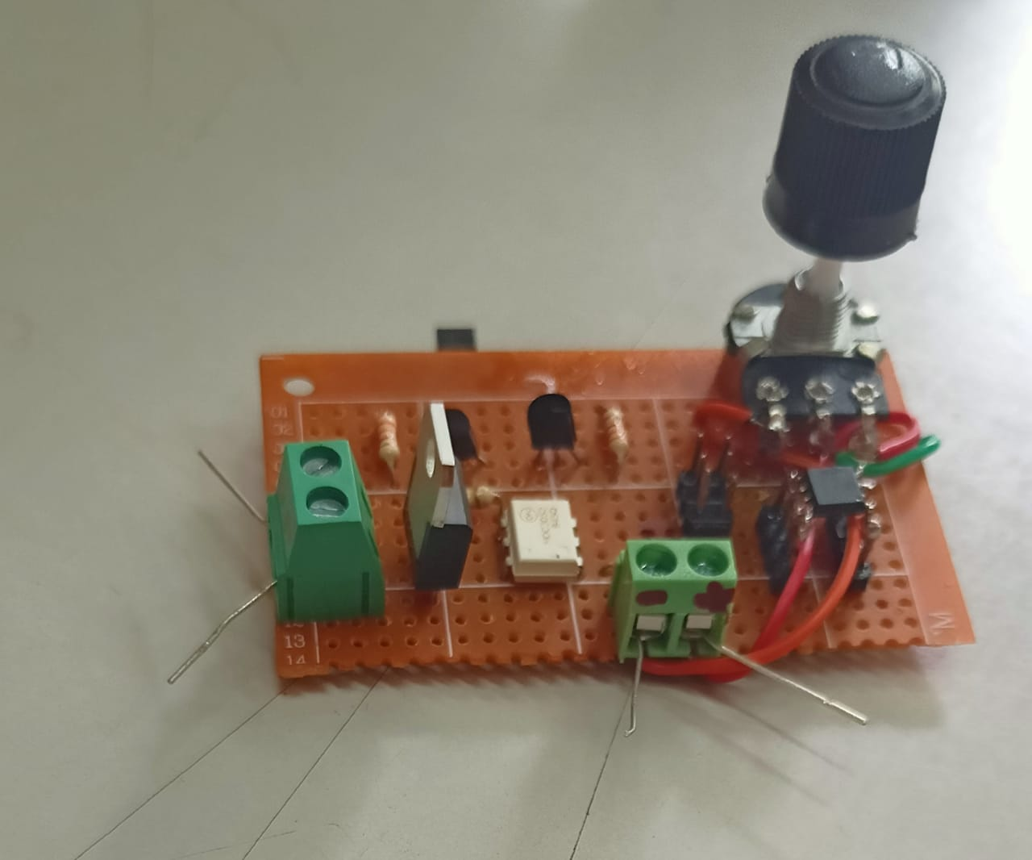

**PCB Design**

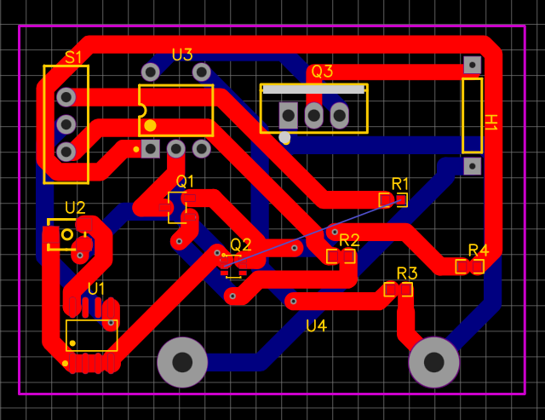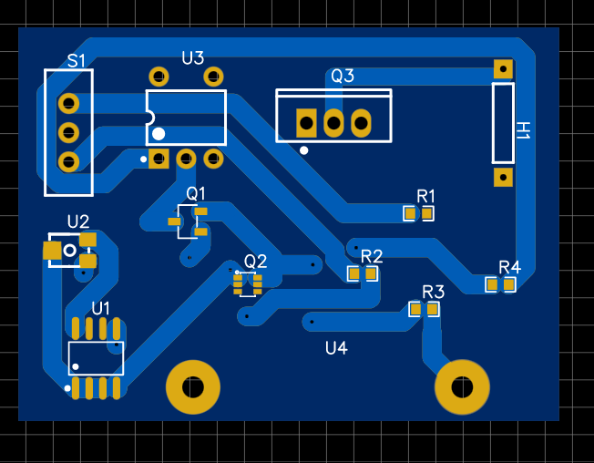

**3D View**

1. **Front View**

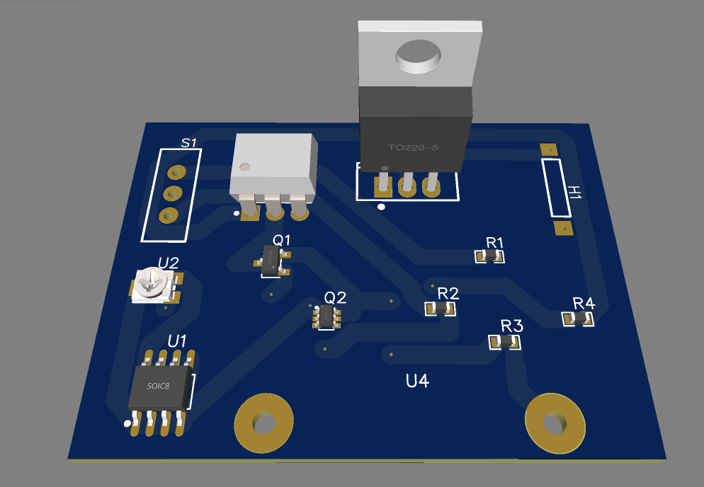  
  
  
  
  
  
  
  
  
  
  
  
  
  
  
  
  
  
  
  
**2) Back View**

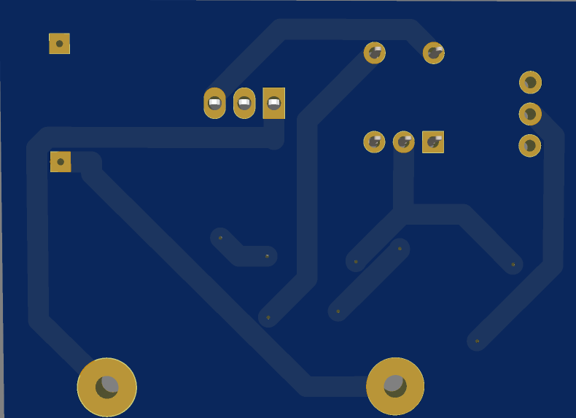 **Code**

int Sensor=0;

void setup() {

pinMode(A2,INPUT);//Configuring the pin A2 to the potentiometer

pinMode(0,OUTPUT);//Configuring the pin 0 to the Relay

}

void loop() {

Sensor=analogRead(A2);//Reading the input of potentiometer by using 'analogRead' keyword

float D=Sensor*(100000/1024);//Assigning the time by making some calculation

delay(D);//Giving delay to the relay

digitalWrite(0,HIGH);//Using the relay

}

**BOM**

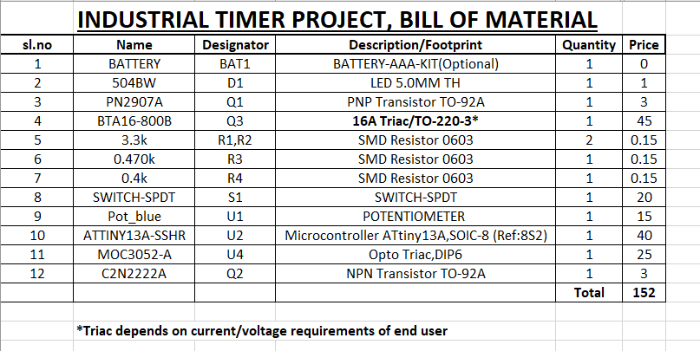

**Comparison  
